CALL FOR SUBMISSIONS:
Community engagement for inclusive rural transformation and gender equality
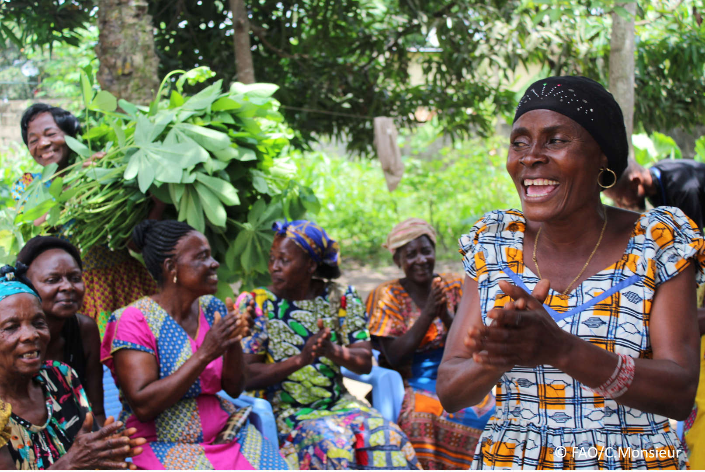
The objective of this call for submissions is to collect good practices, experiences, and lessons learnt on the use of community engagement for inclusive rural transformation and gender equality. The initiative, organized by the Rural Transformation and Gender Equality Division (ESP), seeks to gather insights from a diverse range of contributors, both within FAO and from external stakeholders. Its goal is to share knowledge, foster learning, and guide the scaling up of community engagement and community-led collective action to leave no one behind. The call builds on FAO's past efforts in this area, such as the Community Engagement Days series of webinars.
The call for submissions is open until 27 November 2024.

How to take part in this call for submissions:
To take part in this Call for submissions, please register to the FSN Forum, if you are not yet a member, or “sign in” to your account. Please review the topic note to understand the criteria we are considering for this call. If you wish to learn more about community engagement, you may refer to the background document. Once you have completed this submission template, upload it in the box “Post your contribution” on the call webpage, or, alternatively, send it to fsn-moderator@fao.org.
Please keep the length of submissions limited to 1,500 words and feel also free to attach relevant supporting materials.

Template for submissions

Contact person | Name: Mohamoud Yusuf  Organization/Unit: FAO  Country: Somalia  Email address: Mohamoud.Ismail@fao.org
Name/title of the good practice | Emergency Livestock Technical Assistant
Where is the good practice taking place? (Multiple selection allowed) | ☒ Europe and Central Asia  ☐ Latin America and the Caribbean  ☒ North Africa and Near East  ☒ Sub-Saharan Africa  ☐ Asia and the Pacific  ☐ North America  ☒ Global
Affiliation | ☒ Farmer and producer organizations  ☐ Trade Union  ☒ Informal community-based, farmer-based or self-help group  ☐ Research and academia  ☐ Government  ☒ Local/traditional authorities  ☐ Private Sector  ☐ Civil Society Organization  ☒ Intergovernmental Organization (e.g. UN system, World Bank)  ☐ Resource Partner/Donor  ☐ Other (please specify)
In which sector(s) and context (s) have you used this community engagement good practice? (Multiple selections allowed) | ☐ Education  ☐ Health and Sanitation  ☒ Food production in agrifood systems (please also tick the sub-categories)  ☒ Crop cultivation  ☒ Fisheries and aquaculture production  ☒ Livestock  ☐ Forestry  ☐ Agroforestry  ☐ Horticulture  ☒ Apiculture (beekeeping)  ☐ Agroecology and sustainable farming practices  ☐ Soil and water management  ☐ Other: ____________  ☐ Post-production in agrifood systems (please also tick the sub-categories)  ☒ Processing and value addition  ☒ Marketing and retailing  ☒ Transporting  ☒ Food loss and waste  ☒ Packaging  ☒ Storage  ☒ Distribution  ☐ Other _________  ☒ Gender Equality  ☒ Climate Action  ☐ Citizenship and Governance  ☒ Social Protection  ☐ Humanitarian and protracted crisis  ☒ Conflict resolution, peace and resilience  ☐ Digital innovation  ☐ Other sector (please specify) _________
Who are the financial partners supporting this good practice, if applicable?
- In a few sentences, summarize your community engagement good practice.
Community engagement practices can vary depending on the context, but here are some general good practices to consider when engaging with communities.
Listen and Understand: Effective community engagement starts with listening to the community members to understand their needs, concerns, and aspirations.
Build Trust: Trust is crucial for successful community engagement
Involve Key Stakeholders:
Provide Feedback: Communicate back to the community about how their input has been used and the impact it has had.
Respect Diversity:
Sustain Engagement: Community engagement should be an ongoing process, not just a one-time event.

- What problem(s) or challenge(s) does your good practice aim to address through community engagement?
The good practices outlined for community engagement aim to address several common problems and challenges, including
Lack of Understanding.
Limited Trust
Exclusion of Voices:
Ineffective Communication
Sustainability of Initiatives
Limited Participation
Feedback and Accountability
- In a few sentences, summarize your community engagement good practice.
Community engagement practices can vary depending on the context, but here are some general good practices to consider when engaging with communities.
Listen and Understand
Build Trust: Trust is crucial for successful community engagement
Involve Key Stakeholders
Provide Feedback
Respect Diversity
Sustain Engagement: Community engagement should be an ongoing process, not just a one-time event.

- Who are the key actors and stakeholders involved in the design and implementation of the good practice, and what are their respective roles? Consider local partners, government, local authorities, community radios, civil society, research, the private sector, etc.
In the design and implementation of community engagement good practices, various key actors and stakeholders play important roles. Here are some of the key stakeholders and their respective roles:
Role: Local partners, including community-based organizations, NGOs, and grassroots groups, often have deep knowledge of the community
Role: Governments and local authorities play a crucial role in policy-making, resource allocation, and providing support for community engagement initiatives.
Role: Community radios and media outlets can serve as important communication channels to reach community members, share information about engagement activities, and amplify community voices.
Role: Civil society organizations often have expertise in community engagement and advocacy. They can facilitate dialogue, mobilize resources, and advocate for the needs and rights of the community.
Role: Research institutions can provide data, analysis, and evaluation support for community engagement initiatives.
Role: The private sector can contribute resources, expertise, and support for community engagement initiatives.

- By using community engagement, what results and impacts have your good practice achieved?
Livelihoods Improvement:Qualitative Outcome: Increased access to economic opportunities through skills training programs or entrepreneurship support.
Quantitative Outcome: Higher income levels reported by community members participating in livelihood enhancement initiatives.
Well-being Improvement:Qualitative Outcome: Enhanced social cohesion and community resilience through collaborative projects and increased trust among community members.
Quantitative Outcome: Improved mental health indicators, such as reduced levels of stress and anxiety reported in post-engagement surveys.
Intervention: A community engagement program in a rural village focused on sustainable agriculture practices.
Livelihoods Improvement:
Intervention: Vocational training program targeting unemployed youth in the community.
Results:

- Among these results, has the good practice led to improvements in terms of gender equality, women’s empowerment, and/or social inclusion?
I can outline how effective community engagement practices can lead to improvements in gender equality, women's empowerment, and social inclusion, emphasizing behavioral changes in terms of gender that such practices can promote:
Gender Equality and Women's Empowerment: Agency: Encouraging women to actively participate in decision-making processes and take leadership roles within community initiatives.
Leadership: Promoting women's leadership skills through training, mentorship, and opportunities to lead projects and activities.
Participation in Governance: Facilitating women's engagement in local governance structures, ensuring their voices are heard and considered in decision-making.
Awareness Campaigns: Conducting awareness programs to challenge stereotypes and discriminatory beliefs that limit women's participation and leadership.
Capacity Building: Providing training on gender equality and women's rights to community members, leaders, and stakeholders.
Policy Advocacy: Advocating for policies that promote gender equality and address unequal power dynamics within the community.
intervention has supported the well-being (including psychological resilience) of marginalized groups and enhanced their inclusion and participation in decision-making processes.
- What key challenges did you encounter while implementing the community engagement activities, and how did you address them?
Implementing community engagement activities often involves navigating various challenges that can impact the effectiveness and sustainability of interventions. Here are some key challenges commonly encountered during community engagement initiatives and strategies to address them:
Lack of Trust: Challenge: Building trust with community members and stakeholders can be challenging, particularly in contexts where there is a history of broken promises or mistrust.
Limited Participation: Challenge: Encouraging active participation from all community members, including marginalized groups who may be hesitant to engage, can be difficult.
Power Dynamics: Challenge: Unequal power dynamics within the community can hinder inclusive decision-making and limit the voices of marginalized groups.
Resource Constraints: Challenge: Limited funding, time, or human resources can impede the implementation of community engagement activities effectively.

- What are the key lesson learned from your community engagement good practice?
Community Ownership: Lesson Learned
Tailored Approaches: Lesson Learned: One-size-fits-all solutions do not work in community engagement. Tailoring approaches to the specific context, needs, and preferences of the community is crucial for success.
Continuous Communication: Lesson Learned:
Inclusivity and Diversity:
Capacity Building: Lesson Learned: Investing in building local capacities, skills, and leadership within the community enhances the sustainability and effectiveness of initiatives.
Monitoring and Evaluation: Lesson Learned: Implementing robust monitoring and evaluation mechanisms helps track progress, identify areas for improvement, and demonstrate the impact of community engagement efforts.
Collaborative Partnerships:

- Has this practice been replicated in the same context or in different contexts?
What are the required conditions to replicate and adapt the practice in another context/geographical area?
Replication of Community Engagement Practices:
Advantages: Replicating a successful practice in the same context can be more straightforward due to existing relationships, knowledge, and understanding of local dynamics.
Considerations: Ensure that the conditions that led to success in the initial context are still present, adapt as needed to address any changes, and maintain community involvement to sustain impact.
Community Engagement:Involve key stakeholders and community members from the new context in the adaptation process to ensure relevance, ownership, and sustainability.
Cultural Sensitivity:Consider cultural norms, beliefs, and practices in the new context to ensure that the adapted practice is respectful and aligned with local values.

- How sustainable are the results achieved by this good practice?
Key Elements for Sustainability:Description: Engage and empower community members to take ownership of the initiative, ensuring that they drive decision-making, implementation, and monitoring processes.
Capacity Building:Description: Build the skills, knowledge, and capabilities of community members, local organizations, and leaders to effectively manage and sustain the initiative over time.

- Based on the conversations FAO held during the Community Engagement days, a definition of community engagement for empowerment was proposed:

“Community engagement for empowerment and community-led collective action can be defined as an inclusive and participatory process that enables community members to become active agents of change in decisions affecting their lives, health, and environment. This process develops their capacity to achieve sustainable outcomes for improved rural livelihoods. Embracing a rights-based approach, it prioritizes the agency and participation of all community members, regardless of gender identity, sexual orientation, age, ethnicity, caste, socioeconomic status, political affiliation, migration status, or ability/disability. Indeed, inclusive approaches recognize the complexities of overlapping marginalization and discrimination that can exclude different community members from decision-making processes and implement strategies to foster their participation, agency and empowerment.”

We invite you to contribute to this definition. What would you add or change? Community engagement for empowerment is a participatory process that involves fostering inclusive dialogue, collaboration, and action among individuals, groups, and stakeholders within a community to build capacity, enhance agency, and enable sustainable development outcomes. It aims to empower community members by recognizing their knowledge, skills, and voices, promoting ownership of decisions and actions, and fostering a sense of collective responsibility for positive change.
- Based on your experience, what gaps or areas for improvement still need to be addressed in the field of community engagement?
several gaps and areas for improvement remain. These areas include:
Equity and Inclusivity: Ensuring that marginalized groups, including women, youth, elderly, and persons with disabilities.
Sustainability: Strengthening efforts to enhance the long-term sustainability of community engagement projects by building local capacities.
Technology Integration: Leveraging technology effectively to enhance community engagement processes.
Monitoring and Evaluation: Improving monitoring and evaluation mechanisms to better measure the impact of community engagement initiatives, track progress, and identify areas .
- What do you think is FAO's role in the field of community engagement? How can FAO support and enhance interventions like yours, if applicable? Consider aspects such as policy advocacy, capacity development, funding, technical assistance, knowledge production and sharing, and fostering partnerships.

Policy Advocacy:
Role: FAO can advocate for policies that promote inclusive community engagement, sustainable agriculture practices, and rural development.
Support: Providing evidence-based research, policy recommendations, and technical expertise to influence policy decisions at national and international levels.
apacity Development:Role: FAO can facilitate capacity-building initiatives to strengthen the skills and knowledge of communities, local organizations, and government agencies.
Support: Offering training programs, workshops, and resources to enhance community capacities in sustainable agriculture, natural resource management, and food security.
Funding:
Role: FAO can mobilize funding to support community engagement projects, particularly in low-income countries and regions facing food insecurity.

Link(s) to specific references about your good practice (e.g. reports, communication products, videos, articles) | Please include attachment(s) or add here link(s) to documents/videos/podcasts/other with specific references.

The call for submissions is directly aligned with the thematic components of collective action within FAO's Programme Priority Areas (PPAs), specifically Better Life 1 (Gender Equality and Rural Women’s Empowerment), Better Life 2 (Inclusive Rural Transformation) and Better Life 3 (Agriculture and Food Emergencies).

